IUM-LMS STUDENT USER GUIDE



**International University of Management | IUM-LMS STUDENT USER GUIDE**

**International University of Management**

**IUM-LMS STUDENT USER GUIDE**

**READ CAREFULLY AND PAY ATTENTION TO DETAILS TILL THE END**

**IUM-LMS STUDENT USER GUIDE**

IUM-LMS is a learning platform powered by Moodle, designed to provide Lecturers and Students with a single robust, secure and integrated system to create personalized learning environments.

Moodle is an education software helping Educators and trainers create and deliver effective online learning environments used by millions world-wide.

**Why use IUM LMS**

1. **Designed to support both teaching and learning**
2. **Easy to use**
3. **Robust, secure and private**
4. **Can be used anytime, anywhere, on any device**

***MUST HAVE: Internet access or connection to IUM campus network***

**Getting Started**

‾ On your browser enter the following url: [www.ium.edu.na](http://www.ium.edu.na/)

‾ The IUM home page will appear. Click on Student Conner, under Student Conner click on IUM LMS

‾ The IUM-LMS home page will appear.

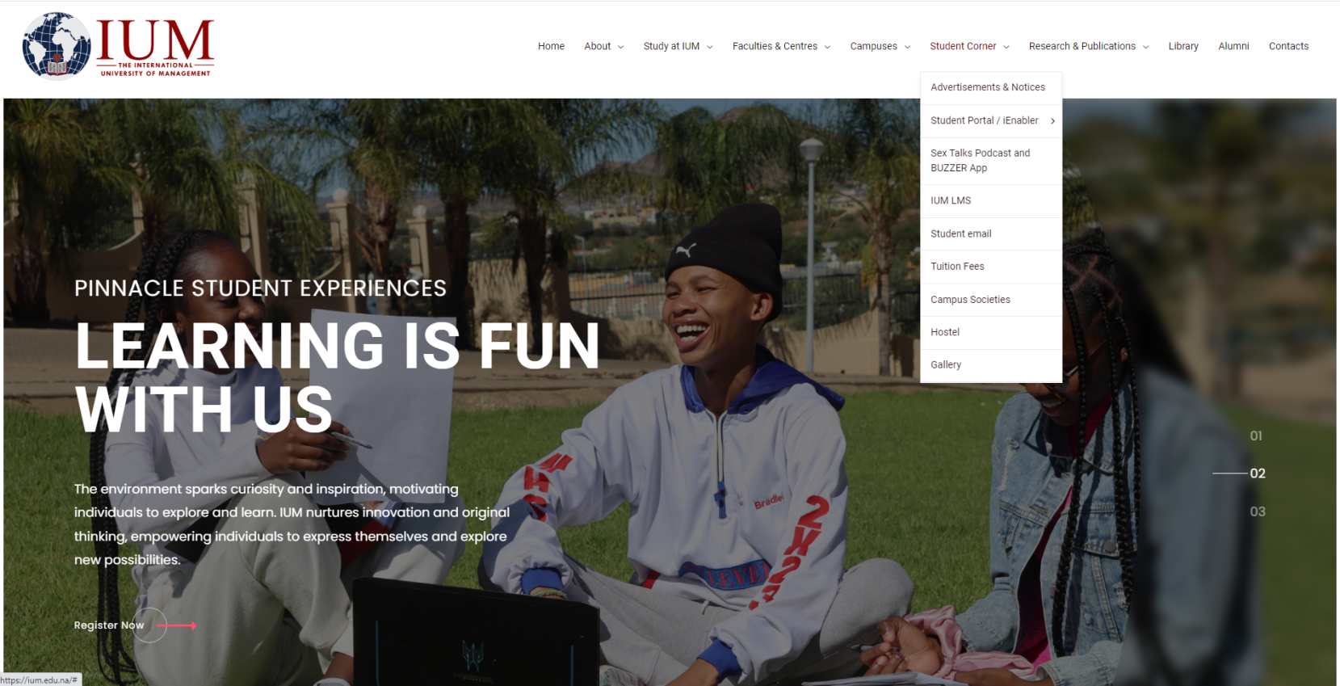

Click here on LMS

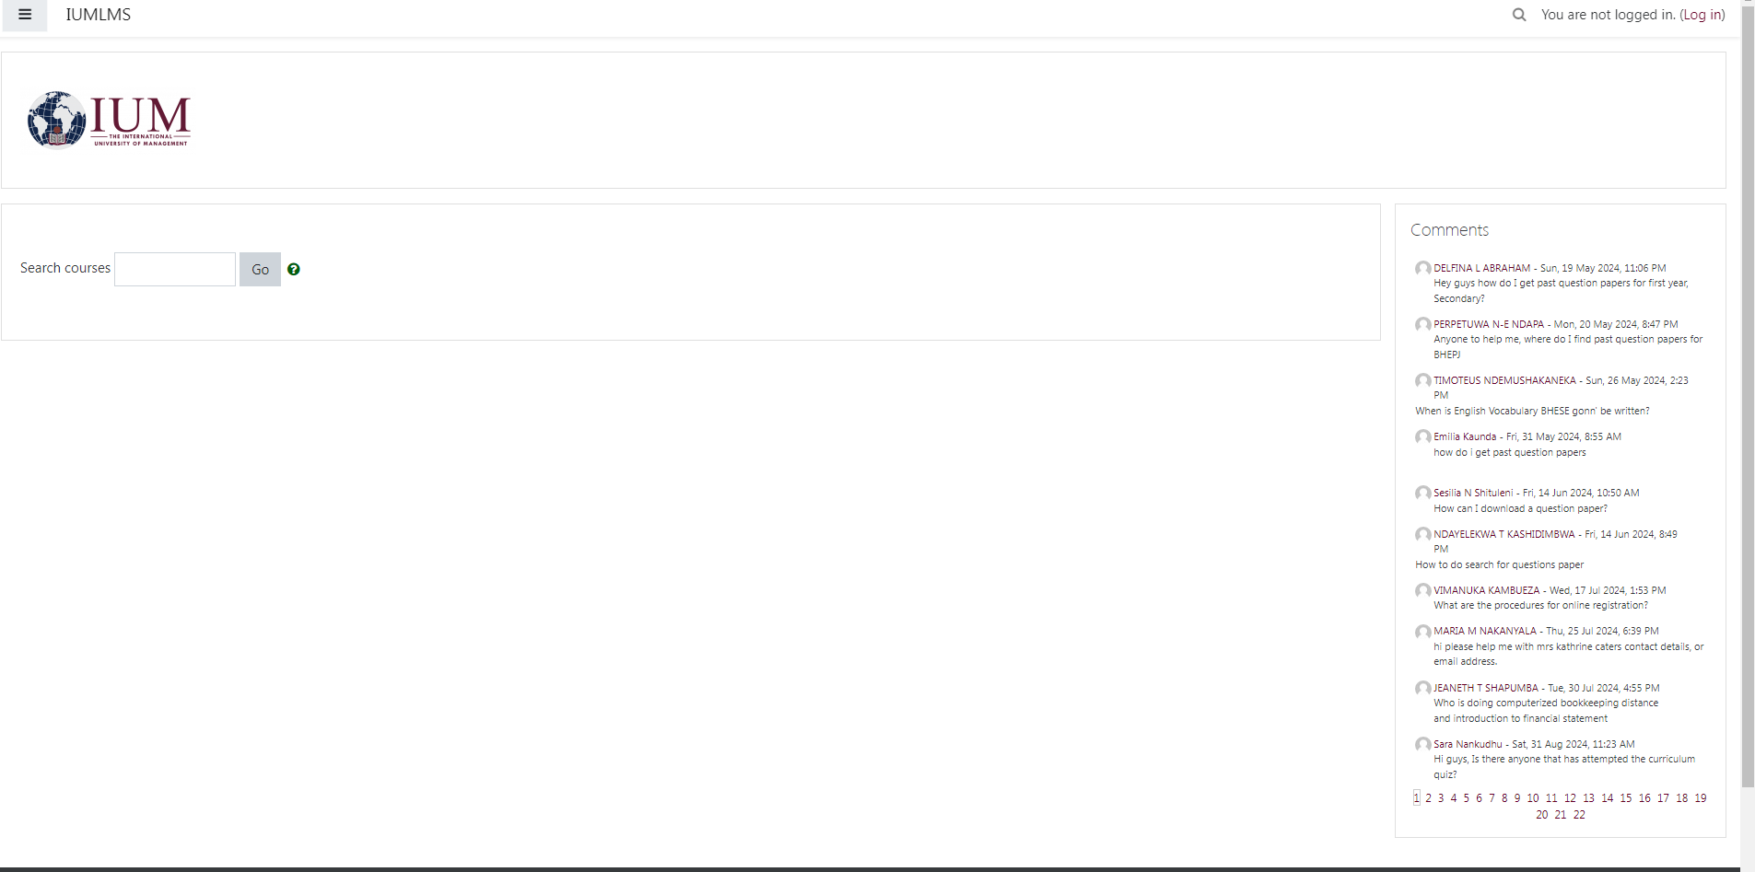

HHHHUI

Click here

**Login in**

**‾ enter username (student number)**

**‾ enter password (LMS.studentnumber@ium) Example**

* **Username: xxxxxxxxx**
* **Password: LMS.xxxxxxxxx@ium**

**Make sure that the LMS is capitalized and ium is in small letters.**

***NB: Make sure you replace xxxxxxxxx with your STUDENT NUMBER when login on the platform.***

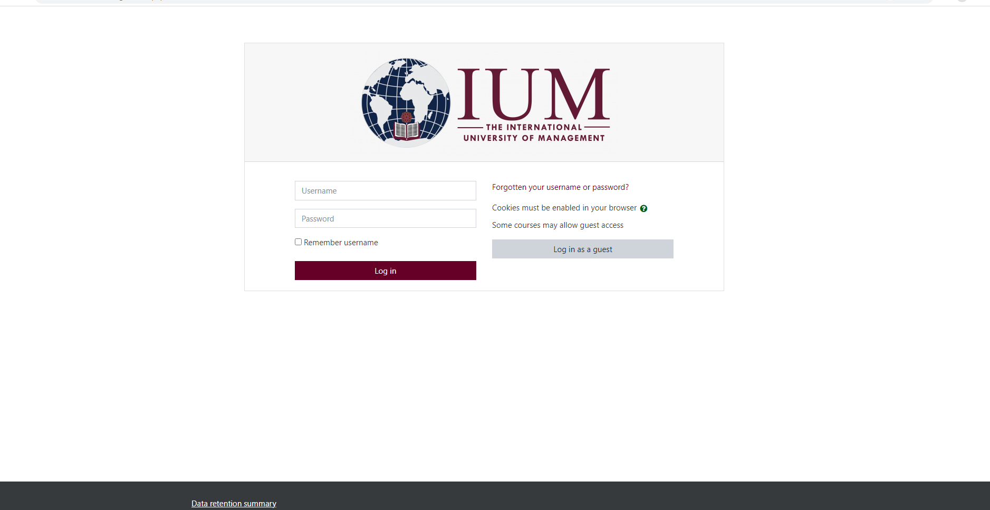

Click here

LMS.XXXXXXXX@ium

xxxxxxxxxx

**Self-enrolment**

**Navigating through the system Dashboard**

‾ After successfully logging in, the system dashboard appears, here you are able to view the system event calendar, online users, announcements, and all recent activities the user is involved.

**My Courses**

Click/Press on “SITE HOME” a list of CAMPUSES and FACULTIES appears, choose your campus, which shows the faculties and courses in the faculties courses that you can choose to enroll for.

**.**

**As shown in the pictures below**

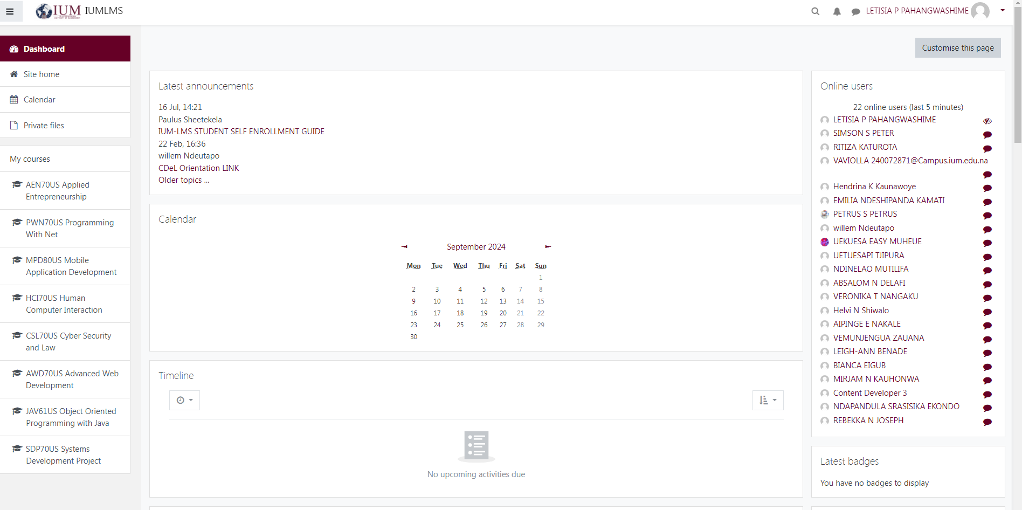

Click here on site home

From there you select your campus like Windhoek, Ongwediva, or nkurenkuru and then navigate to the faculty and choose your faculty and choose whether it is semester1,2 or a year module. As shown below.

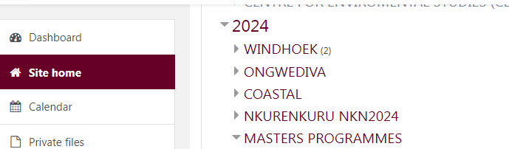

It’s a must to choose where it is written 2024

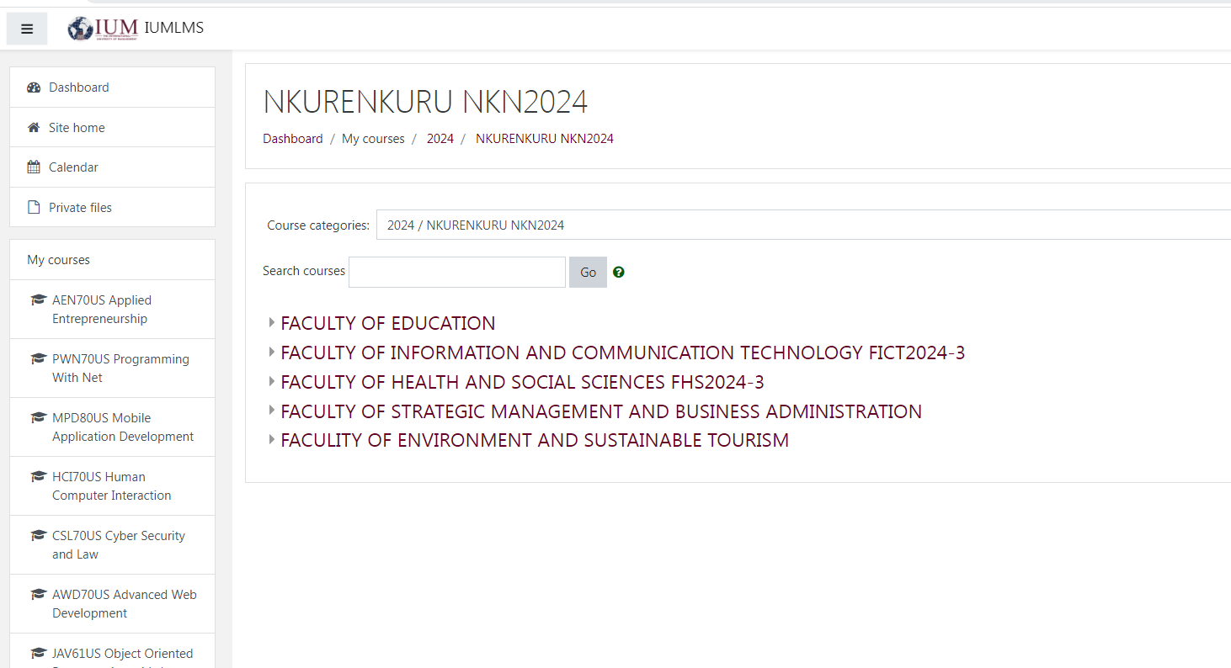

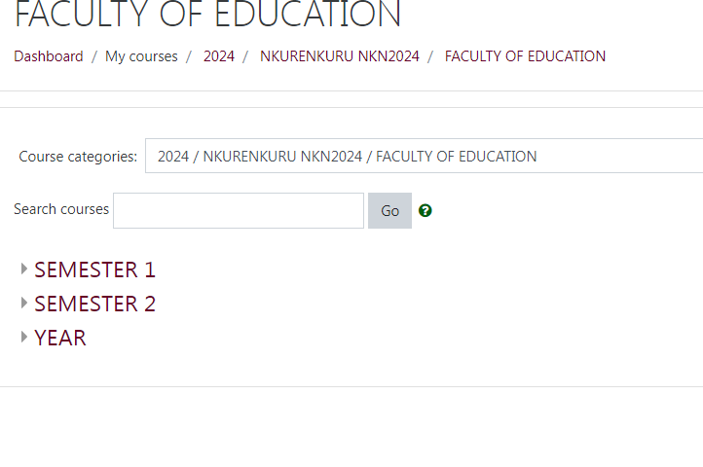

Once you are in your respective faculty choose your modules that you are entitled to / subjects/courses you have registered for.

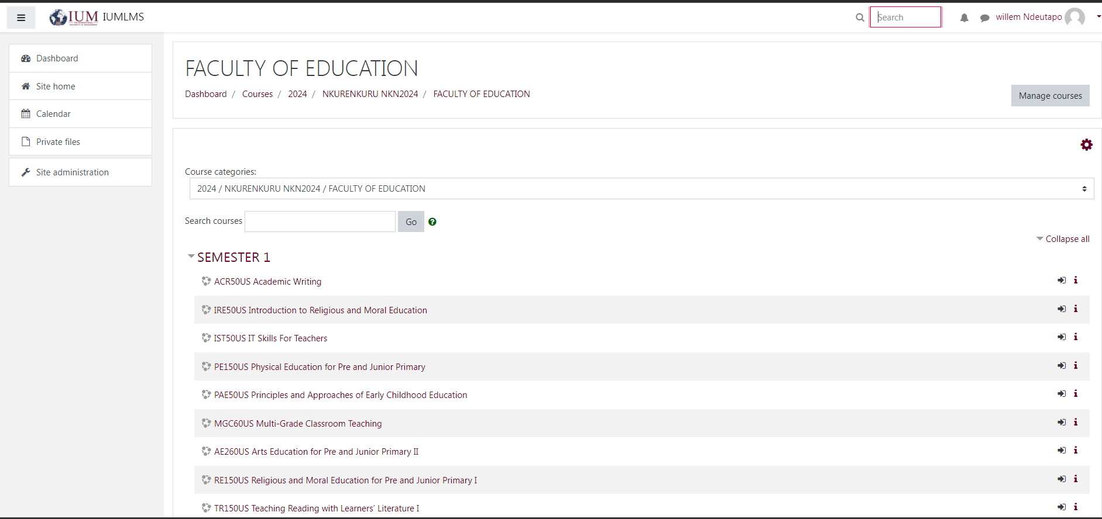

Do not search for your course/subject here because that’s why you enroll yourself on the wrong courses

**When you find your course please find a button “ENROLL ME” click/press it to enroll yourself in that course as below.**

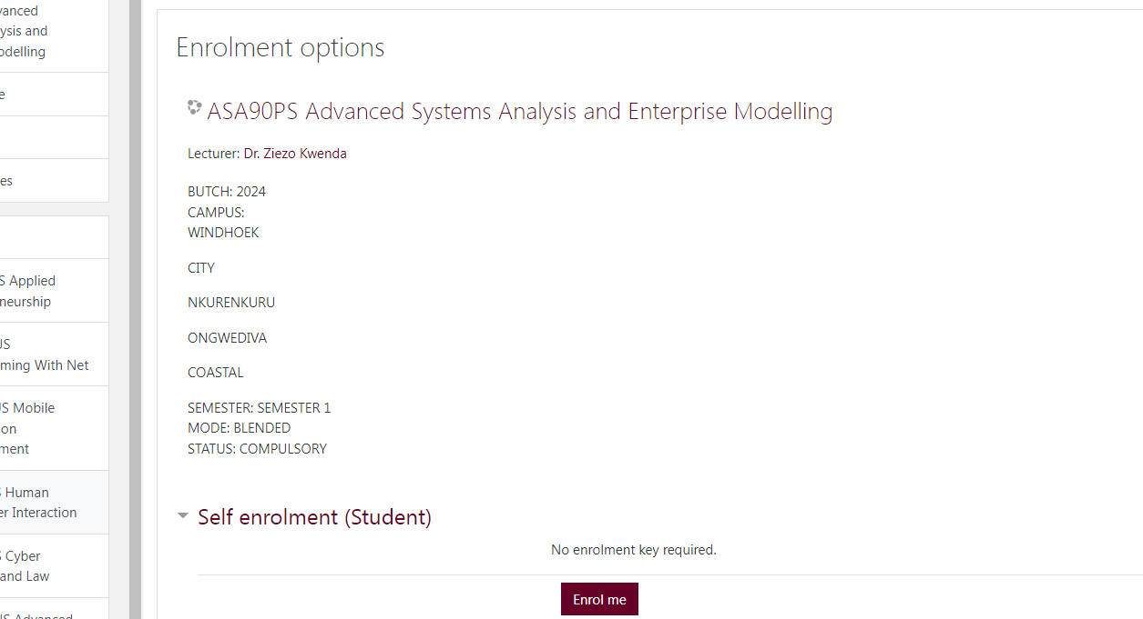

Click here

You will have to enroll in the subject for it to appear in “MY COURSE SECTION”

**Activities**

‾ Click on a course you wish to access.

‾ After clicking a courses the system will present you with all the activities at materials that your lecturer had prepared for you e.g. assignments, lecture notes, forum discussions

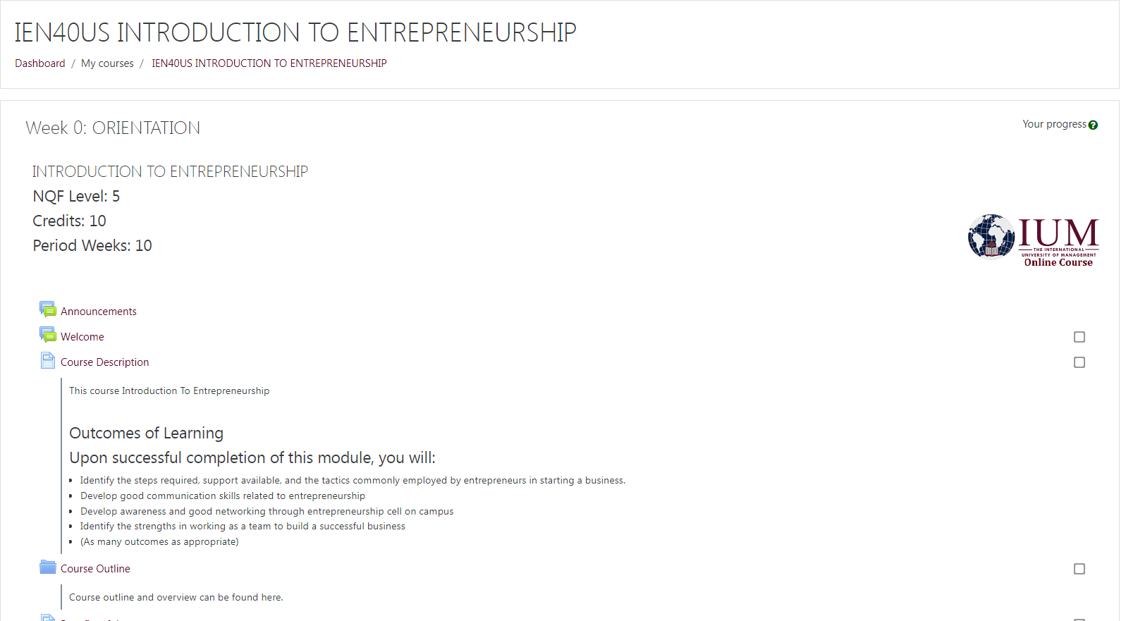

‾ To participate in any activity click on it, the system will join you into that activity to be able to interact with your lecturer and fellow students on the same course.

‾ Here you can click on any of the document uploaded by your lecturer and it can be downloaded into your device.

NOTE: Activities and Learning and Teaching Materials on your course/subjects/modules are added by lecturers. Lecturers have the right to open up activities for students.

***Note: For cyber security reasons please make sure you change your password to a preferred password of your choice: this will protect yourself from third-party and unknown users to access your IUM-LMS portal.***

***Note: Your password must fit given criteria and system requirement as it will be indicated when changing your password.***

For any assistance please feel free to contact us on:

E-mail: [iumlms@ium.edu.na](mailto:iumlms@ium.edu.na)

Tell:

Willem LMS +264817300103

CDeL Coordinator Mr. Charles George

+264 818104181